For the first part of the lab I used Logisim to generate the circuit logic of taking a four bit number and converting it to be displayed on a 7 segment display. It turned out that the 7 segment display in Logisim had reverse logic to the one on the device used so I had to put not symbols (~) on each line of code.

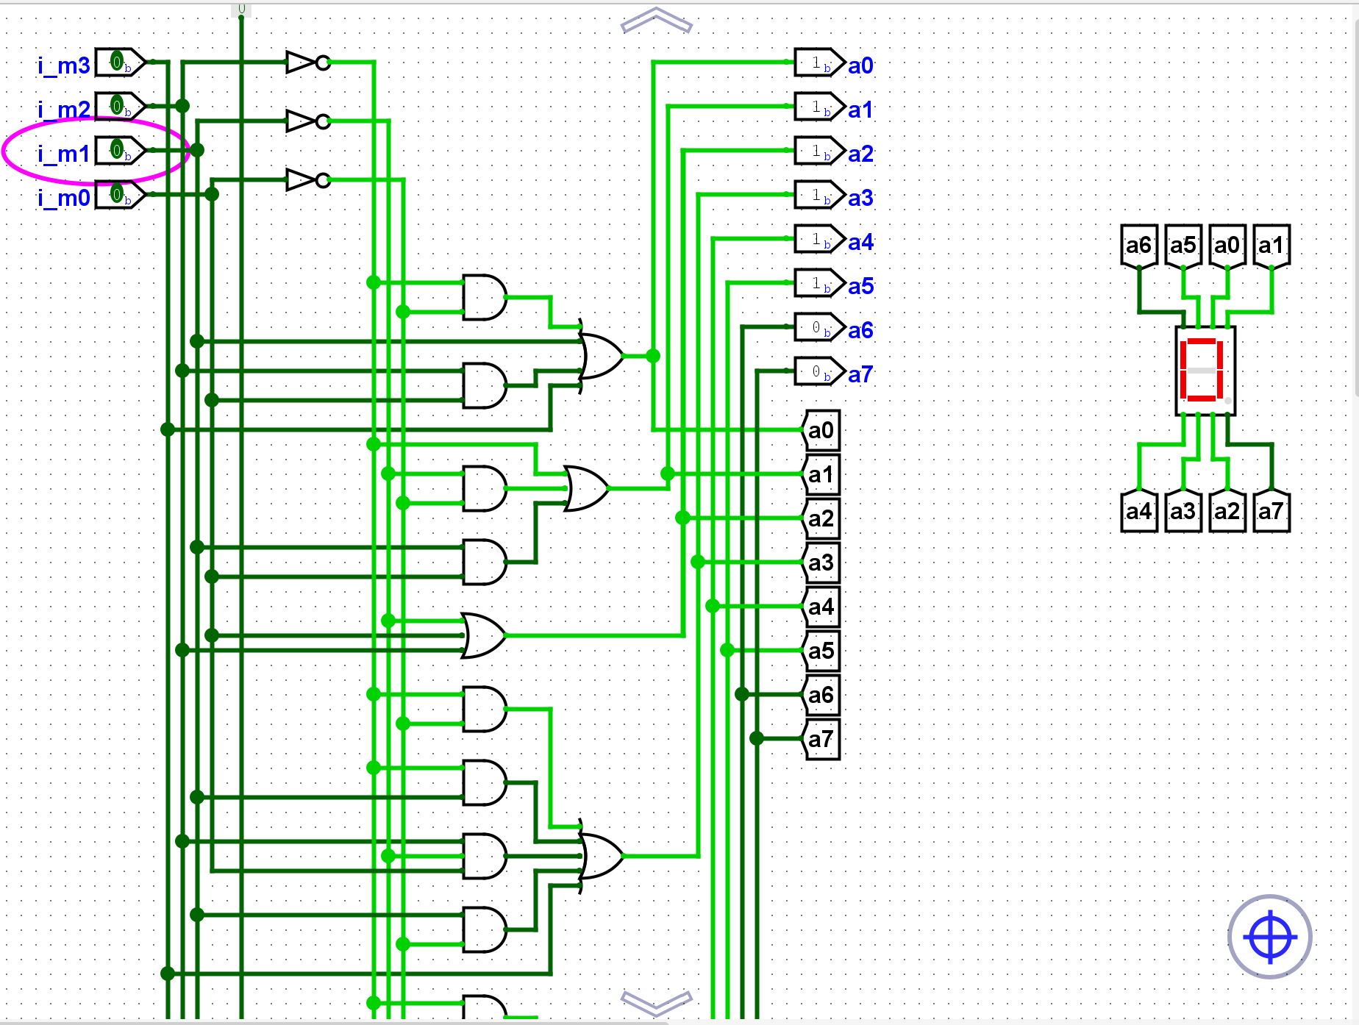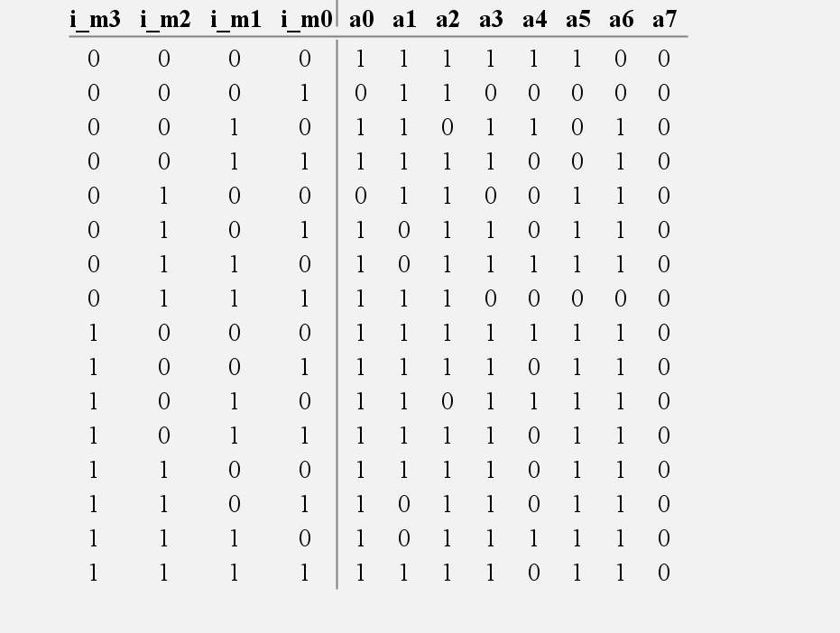

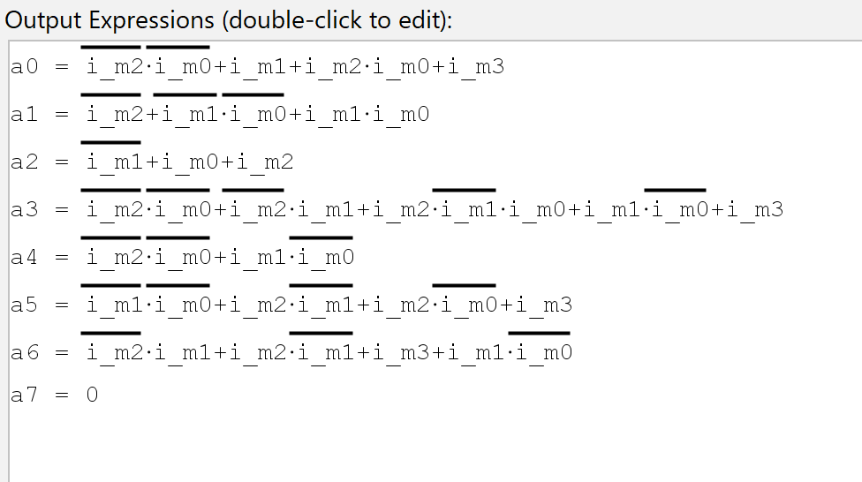

For part two of the lab I generated a 4 bit to bcd converter. Since the maximum output was 15 I only used a 5 bit outcome instead of the usual 8 bits for double digits. Additionally I modified the code form part 1 to only switch between 0 and 1 based on the fifth bit.

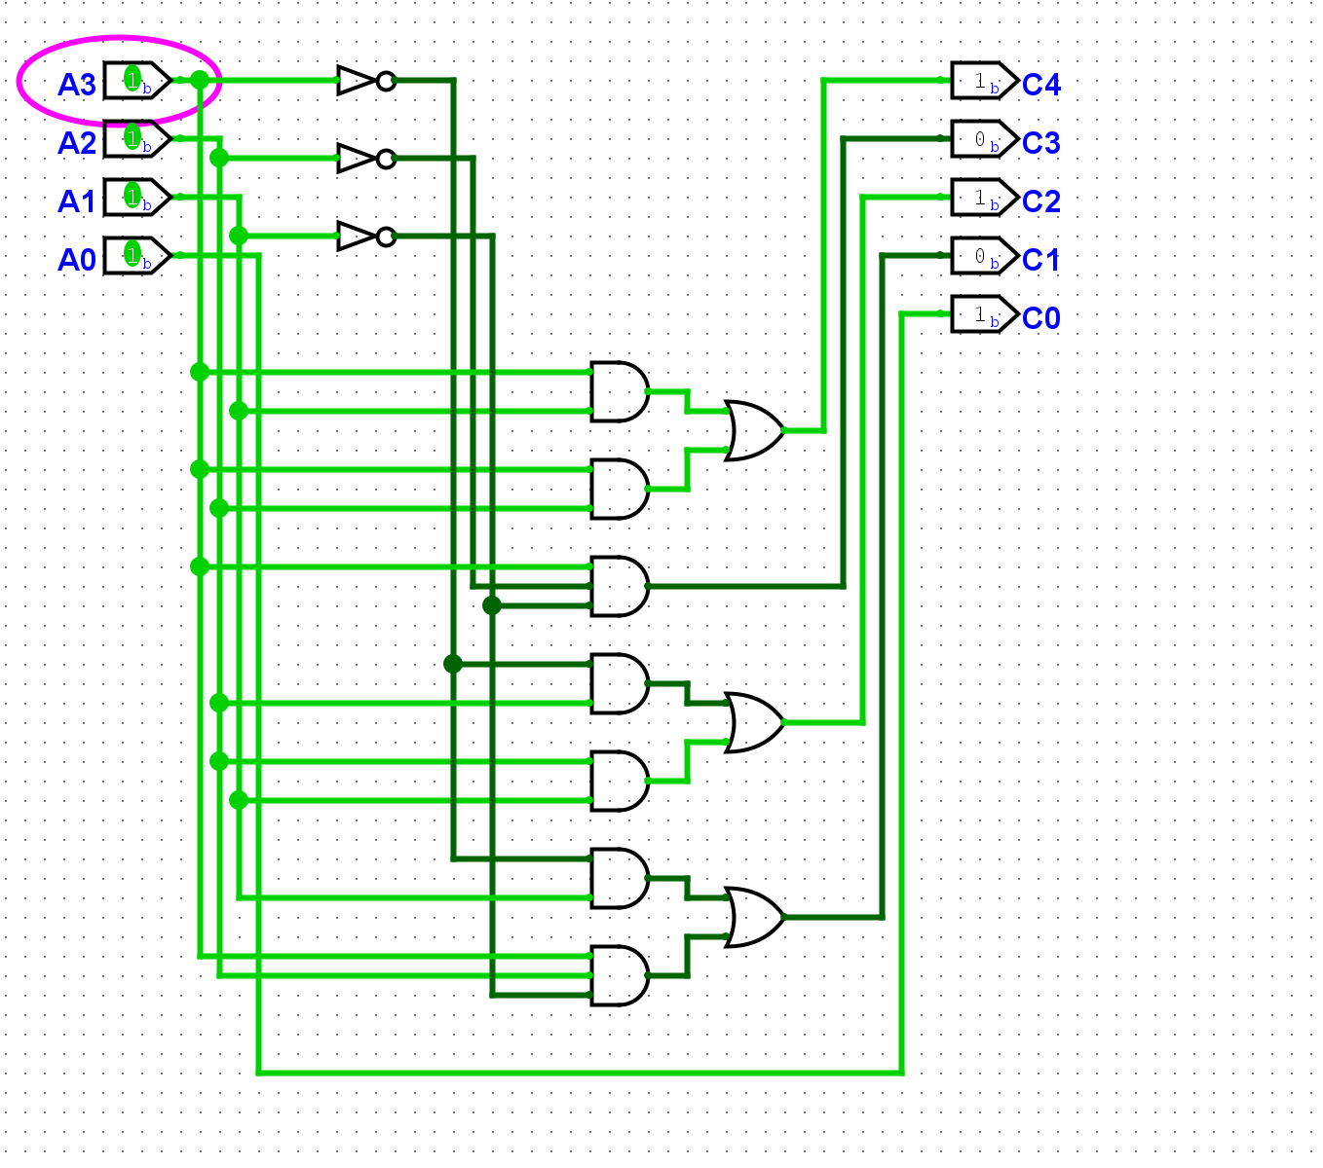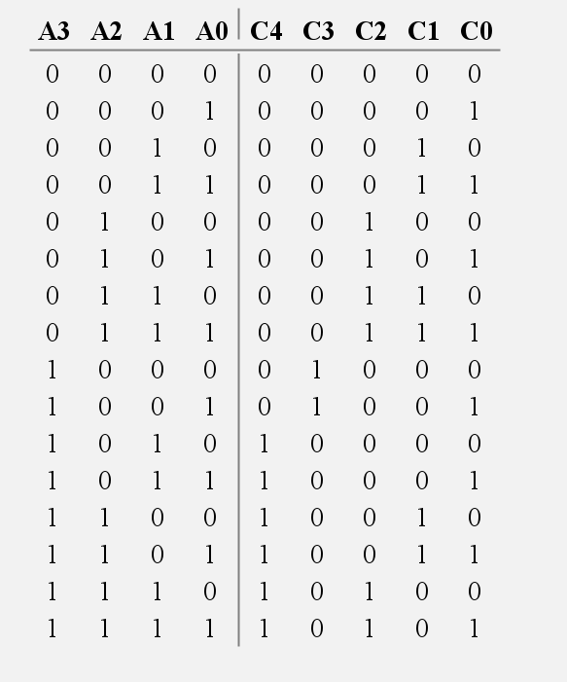

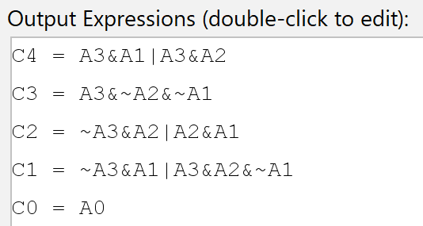

For part 3 I used the given truth table to generate the circuit on Logisim. I then copied the code 4 times and switched out the variables for the corresponding switches and the carry out of the last module. I used 5 leds to display the output.

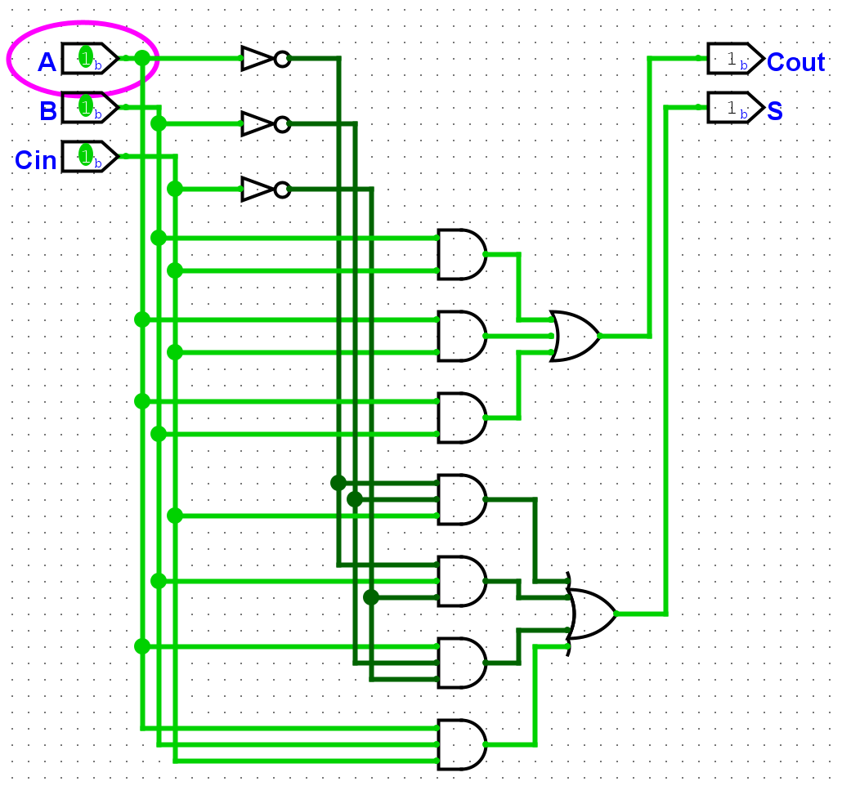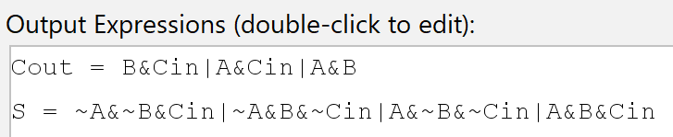

For part 4 I took the code from part 3 fed it into a modified version of the bcd converter from part 3. The new converter would take the five bit number from the adder and convert it into a 5 bit bcd number. I then displayed the number on the 7 segment displays using the code also from part 3.

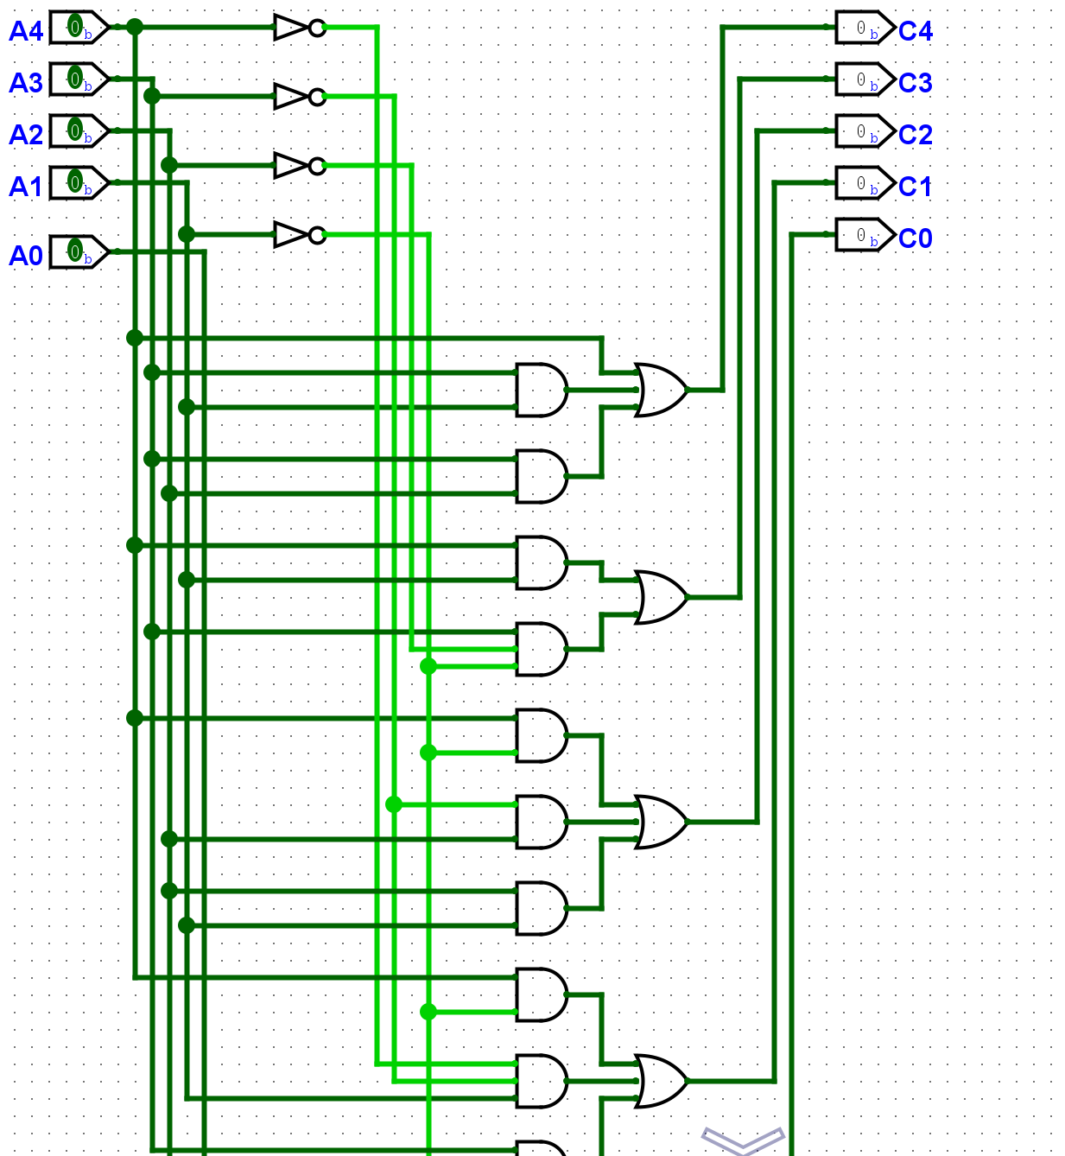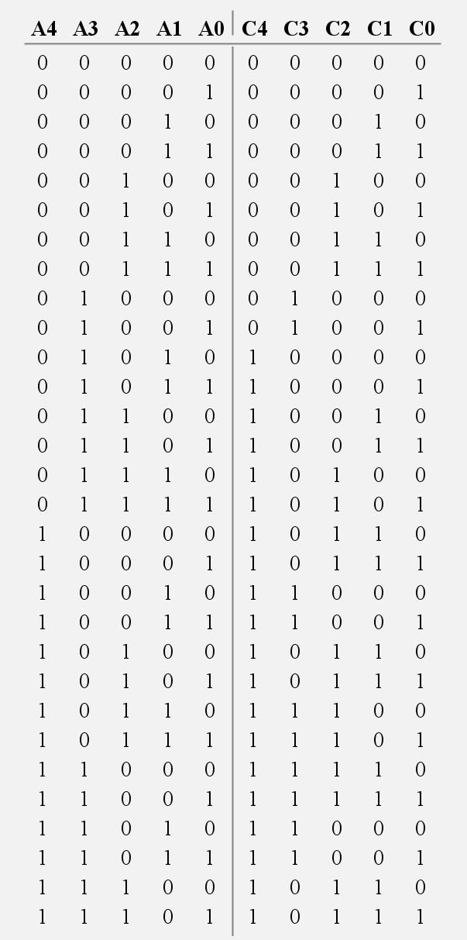

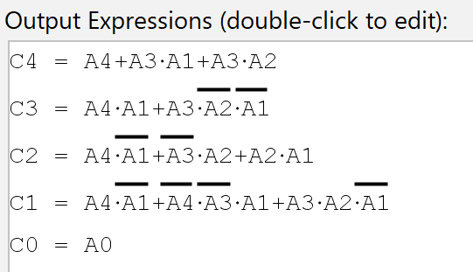

For part 7 I used Logisim to modify the bcd converter again into a 6 bit converter. Then I returned the code for the second 7 segment displays back to what it was in part 1.

